Makro questions from the book
Chapter 2
2.1
a) pass
b) false
c) true this is okuns law
d) false inflation would be a way of measuring a change wile the picture is of a snapshot meaning we cant say anything about inflation
e) uncertain
f) false it’s the opposite if output is higher unemployment is lower
g) true
h) false, this would lead to very high inflation due to the philipscurve
i) false
2.2
a) changes nothing
b) adds 100
c) adds 200 investment(jet is build for them thus is counted when finished)
d) 200 mil plus net export
e) nothing
when nothing it is because a
2.3
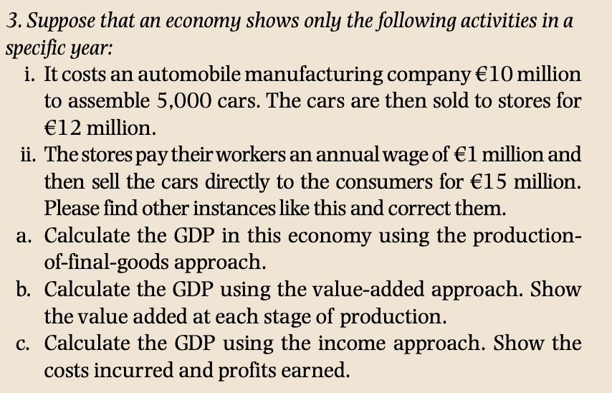
a)
15 million by total goods produced
b)
i)
12 million in capital income
ii)
15 million in capital income
-12million in intermediary goods
Sum $12+3=15 million$
c)
costs + profits
profits:
$$\left(15-12-1\right)+\left(12-10\right)=4$$
Costs:
$$10+1=11$$
Sum:
$$11+4=15$$
2.4
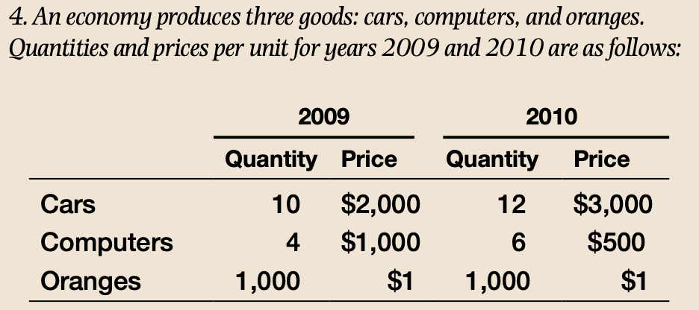
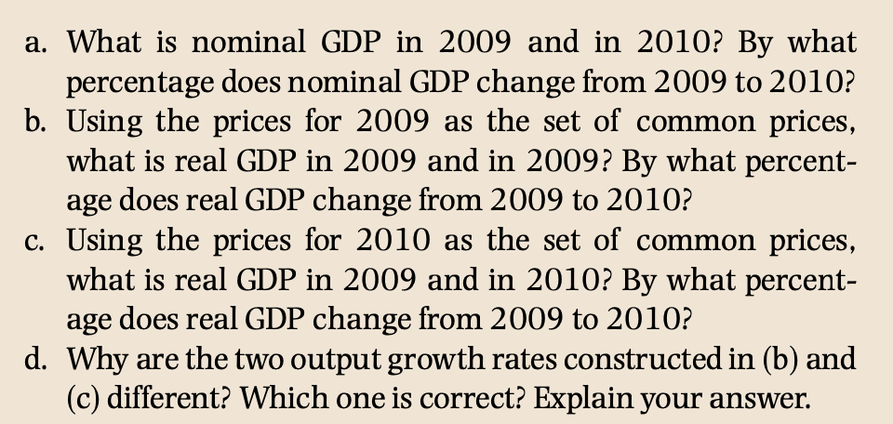
a)
$$10·2000+4·1000+1000=25000$$
$$12·3000+6·500+1000=40000$$
60% growth

2.5
slavearbejde
2.6
…
2.7
…
2.8
a) because of technological progress meaning we get better machines which makes us more productive in general and thus gives higher output
b)
okun law says that we will have higher unemployment in the year with lower growth
c)
then we get the natural rate of unemployment
d)
a steeper slope means inflation is more sensitive to changes in unemployment and as we see later thus more sensitive to a change in output I would say an economy that is less sensitive is better because “you need to pay with less inflation” to get your desired outputlevel
2.9
2.10
2.11

Chapter 3
3.1
a) true
b) pass
c) false we cant spend more than we earn
d) true (I don’t quite remember)
e) true
f) false
g) false becaue of the multiplier effect
h) false an increase in c1 increases output
3.2
$$Y=480+0.5·\left(Y-70\right)+110+250$$
$⇕$ Ligningen løses for Y vha. WordMat.
$$Y=1610$$
$$Y_{d}=Y-T=1610-70=1540$$
$$C=480+0.5·1540=1250$$

3.3
$$S_{p}=Y_{d}-C=1540-1250=290$$
$$S_{G}=T-G=70-250=-180$$

$$S_{p}+S_{g}=290-180=110=I$$
$$Y=\frac{1}{1-0.5}\left(480-0.5·70+110+250\right)=1610$$
Multiplier:
$$2$$
A government would increase spending to increase output maybe to stop deflation of fight off a recession or as part of a mix of fiscal and monetary policies to do “something”

3.4
Yes it is possible as long as $c_{1}<1$
$$Y=\frac{1}{1-c_{1}}(c_{0}-c_{1}T+I+G)$$
If we set $T=G$
$$Y=\frac{1}{1-c_{1}}\left(c_{0}-c_{1}G+I+G\right)=G+\frac{1}{1-c_{1}}\left(c_{0}+I\right)$$
Meaning our output becomes exactly linear in G
We also see that
$$Y_{d}=Y-T=Y-G=\frac{1}{1-c_{1}}\left(c_{0}+I\right)$$
In constant for any tax level

3.5
$$Y=c_{0}+c_{1}\left(Y-T\right)+I+t_{0}+Yt_{1}$$
$$=c_{0}+c_{1}\left(Y-t_{0}-t_{1}·Y\right)+I+$$
$$Y=c_{0}+c_{1}\left(Y-t_{0}-t_{1}·Y\right)+I+G$$
$$Y-c_{1}Y$$

3.6
3.7
3.8

Chapter 4
4.1
a)uncertain
b)true
c)false
d)uncertain
e) true
f) false
g)false opposite if price is higher interestrate is lower
h) false

4.2
a)
$$M_{d}=50·\left(0.2-0.8·0.01\right)=9,6$$
$$M_{d}=50·\left(0.2-0.8·0.05\right)=8$$
b) it declines by 20%
c)
positive linear relationship
negative in this case also linear relationship
d) it should lower interest rates this would make it less attractive to have money in bonds and thus increase the money in circulation
4.3
$$75=\frac{100}{1+r}$$
$⇕$ Ligningen løses for r vha. WordMat.
$$r=\frac{1}{3}$$
…
b) bond prices increase if interestrates fall and vice versa
c)
$$\frac{100}{1+0.08}≈92,59259$$
4.4
$$8=40·(0.25-r)$$
$⇕$ Ligningen løses for r vha. WordMat.
$$r=\frac{1}{20}$$
b)
we will have an excess of money supply meaning we should take money out of cirkulation (perform contractrary open market operations)

Chapter 5
5.1
a)uncertain
b)true
c)false
d)false we have discused this earlier an equal increase in T and G leads to increased output because of the fact that we don’t spend everything we earn(we have a word for this that I don’t remember something along the lines of per”something” to consume”)
e)true
f) false
g)false it falls
h) true
i) false it leads to an increase in output which leads to an increase in investment
5.2
a)
$$Y=c_{0}+c_{1}\left(Y-T\right)+I+G$$
$$Y=\frac{1}{1-c_{1}}\left(c_{0}-c_{1}T+I+G\right)$$
b)
$$Y=c_{0}+c_{1}\left(Y-T\right)+b_{0}+b_{1}Y-b_{2}i+G$$
$$Y=\frac{1}{1-c_{1}-b_{1}}(c_{0}-c_{1}T+b_{0}-b_{2}i+G)$$
We now have a “double multiplier effect an increase in G or c0 would lead to an increase in Y which increases both I and C where before it only increased C thus it should be bigger
c)

5.3
5.4
5.5

Chapter 6
6.1
a) false
b)true
c)true(idk)
d)true
e)false this is exactly the risk premium
f) true
g)true
h) ucertain(im thinking we could have an increase in inflation the same year) but most of the time this will be correct
i) true
j) true this is the mechanism of the bankrun
k) true
L)uncertain
M)uncertain
n)uncertain
6.2

$$1+r=\frac{1+i}{1+π}$$
France:
$$\frac{1+0.017}{1+0.008}-1≈0,00893$$
$$0.017-0.008≈0,009$$
Switzerland:
$$\frac{1+0.017}{1+0.005}-1≈0,01194$$
$$0.017-0.005=0,012$$
c) their currencies arrent pegged thus we can have different nominal inflation thus we don’t need to have the same real interest rates
6.3
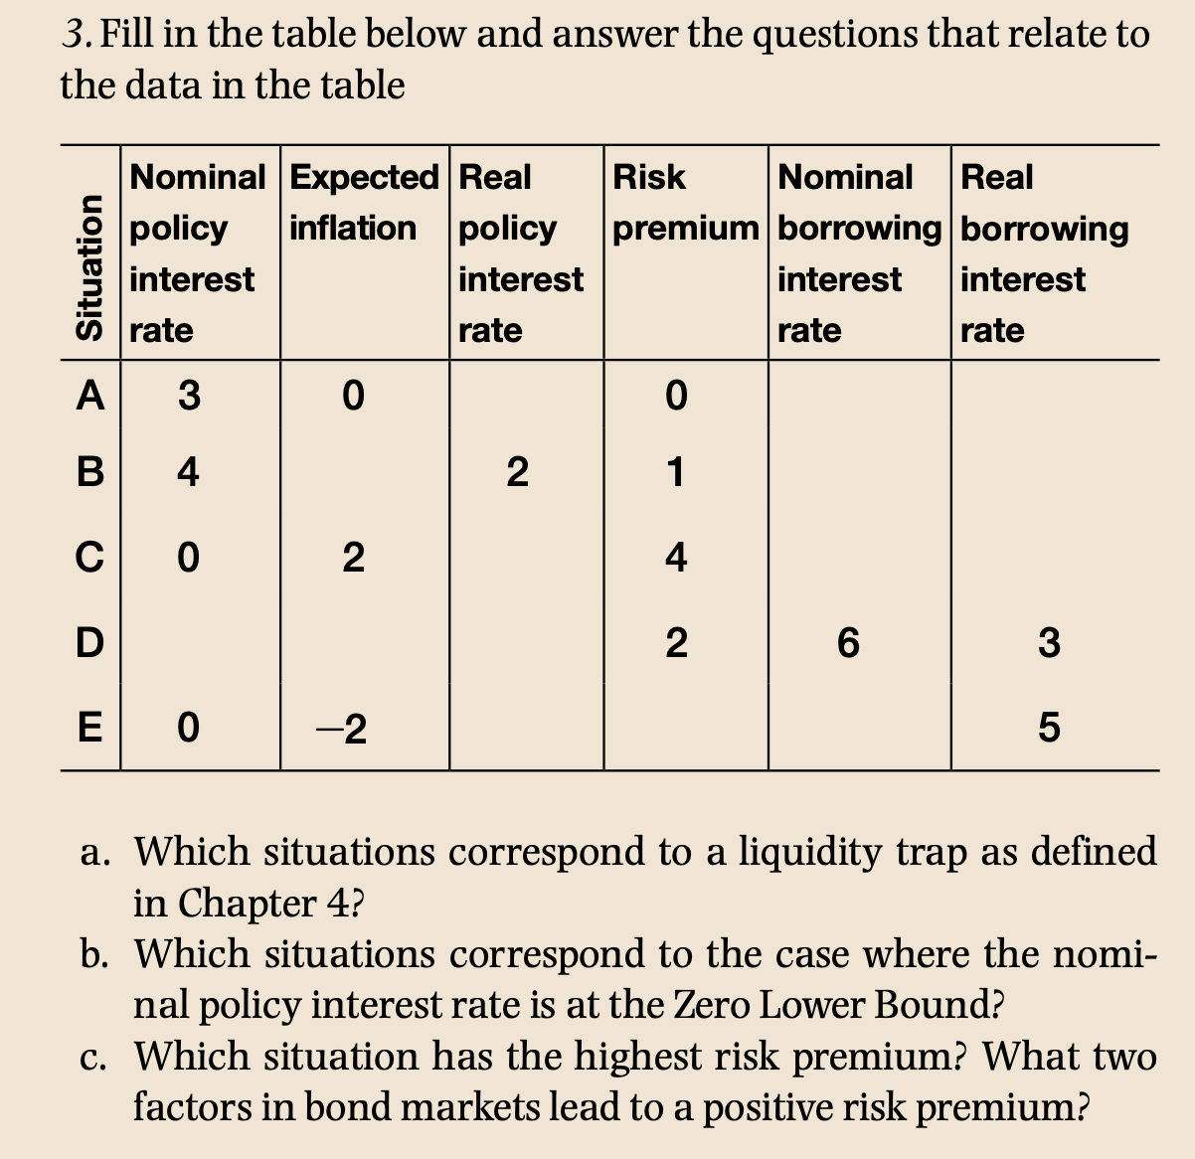
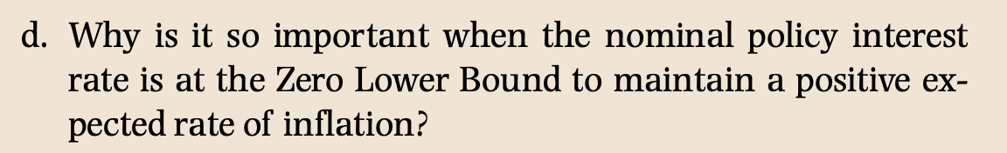
$$A=3,0,3,0,3,3$$
$$B=4,2,2,1,5,3$$
$$C=0,2,-2,4,4,2$$
$$D=4,3,1,2,6,3$$
$$E=0,-2,2,3,3,5$$
a)
b) C and E because of a nominal inflation on the ZLB
c) C: default risk and risk aversion
d) no clue

6.4
6.5

Chapter 7
7.1
a) pas
b) pas
c) pas
d) true okuns law
e) false
f) false
g) true
h) false as before an increase in output would mean a decrease in unemployment per (d)
7.2
Dårlig opgave
7.3
WS
$$W=P·\left(1-2u+z\right)$$
$$\frac{W}{P}=1-2·u+z$$
PS
$$\frac{W}{P}=\frac{1}{1+m}=\frac{1}{1.1}≈0,90909$$
$$\frac{1}{1.1}=1-2·u+0.1$$
$⇕$ Ligningen løses for u vha. WordMat.
$$u=0,09545$$

c) the unemployment decreases
in eq we have
$$F\left(u,z\right)=\frac{1}{1+m}$$
Falling in u and rising in z thus if z falls then u must also fall to conteract and reach EQ
$$\frac{1}{1.1}=1-2·u+0.05$$
$⇕$ Ligningen løses for u vha. WordMat.
$$u=0,07045$$

Chapter 8
8.1
a) true
b) true
c) uncertain
d) true as if they keep doing it they will deanchor expectations and will have to fight to reanchor
e) false
f) pas
g) true
h) false
i) false
j) true
8.2
a) this statement makes sence it says that an economy is able to produce more than it is at the natural rate of output this would only “cost“ inflation and a possible deanchoring
b) pass
c) true this is due to the money illusion
8.3
$$π^{e}-π=-α\left(\frac{m+z}{α}-u\right)=-α·(u_{n}-u)$$
b) we assume $π=π$
c) yes it is linearly dpendent on the markup m
d) yes it is linearly dependant
e) 2 important things when deciding the the markups of firms and general job market conditions such as unemployment benefits and other such things all being covered by the catch all variable z

8.4
a) then the expected inflation is exactly the inflation goal set by the government
b) the inflation expectation is completely deanchored from the central banks
c) brobably somewhere between within some band to adjust for random shocks
8.5
$$π_{t}=π_{t}^{e}+0.1-2u_{t}$$
$$π_{t}^{e}=\left(1-θ\right)\overline{π}+θ·π_{t-1}$$
- For period t-1 we have
$$π_{t-1}=\overline{π_{t-1}}$$
$$π_{t}=\overline{π}+0.1-2·0.03=π·\overline{}+0,04$$
$$π_{t+1}=\overline{π}+0.04=π_{t+2}…=π_{t+5}$$
We are missing the inflation target by the same amount every year and we should expect expectations to deanchor
- Answered above
- Exactly as stated above people no longer believe that the government will make sure we hit the inflation target
- 2
$$π_{t+6}=π_{t+5}+0.1-2·0.03=\overline{π}+0.04+0.04$$
$$π_{t+5+k}=\overline{π}+0.04+0.04·k$$
- We will have accelerating inflation which could end in hyper inflation completely
- Then we will have stable inflation but the government have lost some of its power to influence inflation which means it would have to fight back to reachor inflation expectations

Chapter 9
9.1
a) IS shifts up when an increase in G, down with an increase in T, down with an increase in risk premium x

b) false if unemployment is higher then output is lower
c) true
d)false then output gap is poitive
e) true
f)true(uncertain)
g) depends, if expectations are deanchored or inflation goal is the same in the two years then its true otherwise false
h) true
i) false in some cases if rates are already close to the 0 lower bound there is nothing to be done, this is the danger of a deflationary spiral, instead we wuld need a the government to spend more to get us out of the possible recession
j) uncertain (one could argue that when expectations are anchored inflation dosent accelerate and thus it is easier for the central bank to make up for shocks happening to the economy by adjusting rates or maybe even their inflation target?)
k) true by seeing the increase in oilprices as forcing firms to take a higher markup on workers wages we see by the WS and PS curves that the natural rate of unemployment must rise
9.2
a) this is when expectations are deanchored
b) constant and perfectly achored to the inflation goal set by the central bank
$$π=\overline{π}$$
c) we must have a constant output to be in EQ thus since the only thing chaning is x and we can only change the interestrate we must have that $Δx+Δr=0⇒Δr=-2\%$
if the risk premium rises the IS curve shifts to the left decreasing output to get the output level back to naturel rate of output we must decrease rates by the same amount from 2 to 0
d) to have constant Y, since an increase in G increases output we must increase rates decreasing output
e) same as before a decrease in T increases Y, to decrease Y we must increase r
f) makes sence if the government pumps more money into the economy th economy can handle higher rates
9.3
$$π_{t}=π_{t}^{e}=2\%$$
- an increase in consumer confidence increases consumption increasing output shifting the IS curve to the right
since we have a positive output gap then inflation will increase
thus $π_{t+1}=π_{t}+Δπ>π_{t}$
- to keep the same real policy rate the central bank must increase its rates by $Δπ$ such that
$$i_{t}-π_{t}^{e}=i_{t+1}-π_{t+1}^{e}$$
We will see output be conatant but inflation will accelerate
- we will see that inflation is on a higher level but constant still
interest rates do not need to be adjusted since expected inflation is constant
$$π_{t+2}=π_{t+3}$$
- output is the same in every period of the 2 models but inflation is just lower in the one with anchored expectations since it never accelerates
- somewhere in between none of them are realistic
- I think f we start in period 1 we need to do the exact same things assuming we start in the natural rate of output

9.4
a) the PC curve will shift up meaning higher inflation at any level of output, in the short run unemployment dosent change so output stays the same and thus inflation rises since the natural rate of unemployment rises
b) with deanchored expectation and still to high means inflation will accelerate
c) expected inflation is still anchored, since output is still higher we simply get same result as in before we simply need to adjust once

Chapter 10

10.1
a) true
b) false
c)true(uncertain)
d) false “convergence” is only shown to make sence in the oecd contries (which is not a good sample because they are rich countries now”
e) true
f) true/false depends on how long a time horizon an
g) true
10.2
a)
food:
$$\frac{600}{60}=10$$
Transport:
$$\frac{170}{80}=\frac{17}{8}=2,125$$
b) food:$\frac{15}{50}=\frac{3}{10}=0,3$
transport: $\frac{3}{100}=0,03$
c)
$$0.3·17=5,1$$
$$0.03·17=0,51$$
10.3
a)
$$Y=50$$
b) tripples
c) constant returns to scale
$$f\left(x·K,x·N\right)=x·K+2·x·N=x·\left(K+2N\right)=x·Y$$
d)
$$\frac{Y}{N}=\frac{K}{N}+2$$
e) it less than doubles
f) no its diminishing to scale
g) ne is constant returns to scale the other is diminishing
h) the function Is linear while the function in the drawing has $f^{''}<0$

Chapter 11
11.1
a) if $G=T$ then true
$$I=s·Y$$
b) false the gains fall of approaching new steady state output
c) true smaller and smaller gains tho but true
d) false
e) true
f) uncertain
g) true
11.2
I would say the statement lacks nuance and argument and even if it is right I probably wouldent vote for him next time
11.3 it would increase output untill we reach a new steady state this will “cost” consumption in the short run but would increase output per person and thus output in the long run
11.4
a) would increase saving which increses output per worker untill new staedy state
b) would increase output ig general because more people to work since N dosent change this just increases output/worker

Chapter 12
12.1
a) false this implies
$$1.1·0.9=0,99=1$$
Which I suppose you could argue is good enough but as a person who likes to be right I would say no
b)
$$\frac{I}{A·N}=s·\frac{Y}{A·N}=\left(g_{A}+g_{n}+δ\right)\frac{K}{A·N}$$
True since if g_A increases then s must increase for Y/AN to stay constant
c) false
d) true
e) first part true second is false
f) assuming buying the machine has a sure return and RnD has unsure return and these two returns are the same then yes the firm will buy the machine
g) true since there is no gain to be made
h) this is a philosophical question that this book most certainly does not answer
i) uncertain

12.2
a) because technological progress is the only true driver of growth
fertility: if it costs a lot to be likely to make a brakthrough
approbiability: how well you are able to profit of of that breakthrough
can be seen as
the probability you are gonna make a profit for every dollar spend
and the gain if you do make a breakthrough

b) a global protection of patents would greatly increase the approbiability thus increase spending on RnD
c) would increase the fertility of research since it indirectly makes research cheaper
d) makes research harder thus decreaseing the fertility of research
e) would greatly decrease the appropialily of research

Chapter 13
13.1
a) false
b) false some fields become obsolete making the demand for workers in those fields less which ends up giving them lower wages where others might be able to thrive in these new jobs
c) true by graph
d) assuming
$$Y=A·N$$
$$g_{Y}=g_{A}+g_{N}$$
$$g_{N}=g_{y}-g_{A}<0⇔g_{A}>g_{y}$$
True
e)true
f)true(idk)
13.2
a)
$$\frac{1}{1+m}=\frac{W}{P·A}$$
$$\frac{W}{P^{e}·A^{e}}=1-u$$
If $P=P^{e}$
$$\frac{1}{1+m}·A=\left(1-u\right)A^{e}$$
$$1-u=\frac{1}{1+m}·\frac{A}{A^{e}}$$
$$u=1-\frac{1}{1+m}·\frac{A}{A^{e}}$$
I made up a notation for when A=A^e being called the exrta natural rate of unemployment
If $A>A^{e}$ then $u<u_{nn}$
If $A<A^{e}$ then $u>u_{nn}$
b)
$$u=1-\frac{1}{1+0.05}≈0,04762$$
c) when expectations are accurate then no the natural rate of unemployment does not depend on the productivity
13.3
An increase in productivity does not chage the natural level of unemployment
The price setting equation $P=w·\frac{1+m}{A}$
And since the wage setting equation
$$w=P·F·A$$
The prices stay constant
Since unemployment dosent change then inflation dosent change

13.4
a)better training means better bargaining power means better wages for low skill and thus low incomeemployees decreesing unemployment
b)
c) this means higher technological growth which we have deduced increases inequality
d)thinking that financial services employ high skill workers and manufacturing employs low skill ones im thinking that supporting the high skill means higher wages for them and lowr for the low skill ones increasing inequality
Chapter 14
14.1
a)true
b)true
c)false
d) true
e)true?
f) true
g) true
h) false(this is not true under the physical probability measure but only the risk neutral one
but if the expeted payments are equal then it is true
i)false the assets become overpriced
j) false
k)true
14.2
The bond is at par price thus
$$c=0.05$$
$$\frac{5}{1.05}+\frac{5}{{1.05}^{2}}+\frac{105}{{1.05}^{3}}=100$$
$$\frac{5}{1.05}+\frac{5}{{1.05}^{1}1.03}+\frac{105}{1.05·{1.03}^{2}}≈103,6447$$

14.4
a) well it doent strictly have to we we would just need a way of doing non yearly discounting
the exdividend isent really an issue either as we can just add the value of the dividend being payed out right now and we wont have a conflict with no arbitrage
b) in this model the stock price is the sum of a series of dividend payments discounted with the risk free rate plus a risk premium
I is the risk free rate
X is the risk premium, D is the dividend
And Q is the expected stockprice
c) then the stock is cheaper
d)it decreases
e) increases
f) its much smaller when its discounted further

14.5
Assuming they are zero cupon bonds
Pricing does not depend on how long one want to hold them.
Personal utility might bot arbitrage free pricing does not

$$P_{1}=\frac{1000}{1.05}≈952,38095$$
$$P_{2}=\frac{1060}{1.05·1.06}≈952,38095$$
No arbitrage works just fine since the price of bond 2 at time 1
$$P_{2}^{1}=\frac{1060}{1.06}=1000$$
So investing first in bond 1 and buying bond 2 at time 1 yields no change in return when expectations are met
c) it would still work it would just change prices of the bonds if you want them to have the same price also then we must have
$$\frac{F}{(1+i_{1})(1+i_{1,2})}=\frac{F}{1+i_{1}}⇒i_{1,2}=0$$
14.6
a) we will only see a little change since we expect rates to return to the expected level soon
we could actually calculate this % difference (assuming no risk premium)
$$\frac{1}{1+0.03}-\frac{1}{1+0.02}≈-0,00952$$
the stock should fall with about 1%
b) the real discountrate will be constantly higher reducing the prices by much more this cant be calculated without more information
c) this is ambigous it could both fall and increase since the 2 factors pull in different directions
Chapter 15
15.1
a) false human wealth is high while nonhuman wealth(most likely because hey havent had time to accumulate assets) is low or even negative because of stuff like student loans
b) pas
c)true, this decreases consumption
d)false
e) false q>1 means the market believes ther should be invested more into the companybecause the market believes that the company is goin to generate more value than the invested amount
f) it shouldn’t yet it does an argument can be made that a company that earns a high profit in 1 period want to try and expand even though it dosent necesarrily make sence on a value standpoint
g)true
h) direction is about the same while investment seems to be much more volatile
15.2
a)
Lucy
Human=total wealth
$$70·\left(1+1.02+{1.02}^{2}\right)·0.7=149,9596$$
Adam
human
$$45·\left(1+1.02+{1.02}^{2}\right)·0.7≈96,4026$$
Nonhuman capital:
$$50$$
Total
$$96,4026+50=146,4026$$
b)
They would simply spread it and since we have no interest rate its quite easy
Lucy
$$\frac{149,9596}{3}≈49,98653$$
Adam
$$\frac{146,4026}{3}≈48,80087$$
c) it would hit lucy harder than adam since she dosent have any wealth to begin with
lucy
$$70·\left(1+1.02+{1.02}^{2}\right)·0.6=128,5368$$
$$\frac{128,5368}{3}=42,8456$$
Adam:
$$45·\left(1+1.02+{1.02}^{2}\right)·0.6+50=132,6308$$
$$\frac{132,6308}{3}≈44,21027$$
d)
$$70·\left(1+1.1+{1.1}^{2}\right)·0.6=139,02$$
$$\frac{139,02}{3}=46,34$$
e) it would increase it in all periods

15.3
a)
$$\frac{15}{0.18}≈83,33333<100$$
thus we should not buy
b)
$$\frac{15}{0.15}=100$$
Now its indifferent between buying and not buying the machine

Chapter 16

Chapter 17
17.1
a)true
b)true
c)idk
d)if they have a fixed exchangerate and open finanial markets then yes otherwise no
e)false its opposite
f) false
g) true
h)true
i)false
j) false its opposite

17.2
17.3
$$E=0.79\frac{lira}{real}$$
Brazilian bond:
$$9630=\frac{10000}{1+r}$$
$⇕$ Ligningen løses for r vha. WordMat.
$$i_{B}=\frac{37}{963}≈0,03842$$
Turkish bond:
$$9450=\frac{10000}{1+r}$$
$⇕$ Ligningen løses for r vha. WordMat.
$$i_{t}=\frac{11}{189}≈0,0582$$
The approximation of the uncovered interest parity states
$$i_{B}=i_{t}-\frac{ΔE^{e}}{E}$$
Since $i_{B}<i_{t}$
$$ΔE>0$$
Thus the real is expected to appreciate since you can get more lira per real
b)
$$0,03842=0,0582-\frac{x-0.79}{0.79}$$
$⇕$ Ligningen løses for x vha. WordMat.
$$x=0,80563$$
c) if we expect the real to deppriciate instead of appreciate then we invest in lira since then we both gain the extra interestrate plus exstar from the appericiation
approcimately
$$i_{realised}=0.0582+\frac{0.04}{0.8}≈0,1082$$
Vs $0,03842$
e) It is not against the parity condition simply a question of expectations sometimes the market is wrong and this time we were right and bennefitted

Chapter 18

Chapter 19
19.1
a)false
b)true
c)false
d) not instant but it will adjust very quickly
e) true
f) false it decreases xports since it increases E
g) if you keep Y’ fixed then false
h)uncertain
i) true otherwise we break uip

19.2
Fiscal contraction and monetary expansion
19.3
a) consumption increases because output increases
investment increases because output increases and because interestrates decrease
b) increased domestic rates decrease the real exchangerate which increases net exports under the marshall lerner condition
19.4
19.5

TØ

Ting jeg ikke fatter:
Hvornår skal man bruge Supply demand kurven
Bank run og insolvancy(især balance sheet)

Inflation in medium run EQ when it rises and when t falls

Hvilke beviser er der han kunne finde på at give:
Udud lig efterspørgsel hvis og kun hvis Saving=investment
Equilibrium in central bank moneydemand with both cash and financial intermediaries
Derive the real interest rate and approximation
Derive an equation for capital stock
Udled værdien af en maskine der depriciater hvert år

Philips curve med wage indexation
Derive the golden rule level of capital
Derive the solow growth residual
Derive the philips curve
Derive the uncovered interest parity

Show the only 2 out of 3 conditions can be met: openness in financial markets, stable exchngerates and interest rate autonomy
Show that GNP=GDP + CA
Or equivalently that
$$I+CA=S+T-G$$
Show relations between current and future exchange rates on a basis of expected interestrates

Begrebsliste:

Kapitel 1
common currency area, 31
an area with the same currency
Kapitel 2
national income and product accounts, 42
an early measure of GDP

aggregate output, 42
the sum of production in an economy

gross domestic product (GDP), 42
the monetary value of the sum of final goods produced in an economy in a given period

gross national product (GNP), 42
GDP + NI
Where NI is net income thus what the countrys assets are producing over seas (expads or outsourced production)

intermediate good, 42
a good that is used in the production of another good thus is not used to produce another good

final good, 43
a good that is not an intermediate good

value added, 43
value of final good - value of all intermidiate goods that go into production of final good

nominal GDP, 44
gdp in dollar terms

real GDP, 44
gdp normalised to some pricelebel
$$\frac{\$Y}{P}$$

real GDP in chained (2009) dollars, 45
GDP normalised to 2009 dollars

dollar GDP, GDP in current dollars, 46
GDP normalised to current dollars

GDP in terms of goods, GDP in constant dollars, GDP adjusted
for inflation, GDP in chained (2009) dollars, GDP in 2009
dollars, 46
wasy of making gdp comparabe across time

real GDP per person, 46
output per person
$$\frac{Y}{N}$$
GDP growth, 46
How much gdp grow across time denoted
$$g_{Y}$$

expansions, 46
when GDP is growing

recessions, 46
when gdp has negative growth

hedonic pricing, 47
a way of pricing often a catogory of goods by how good they are at something fx. Computers and ram or CPU and clockspeeds

employment, 47
how many people are in the fork force
$$N$$

unemployment, 47
how many people are in the forkforce but not in a job
$$U$$

labor force, 47
the total amount of people either in a job or looking for a job

$$L=N+U$$

unemployment rate, 47
$$\frac{U}{L}=u$$

Current Population Survey (CPS), 48
A large survey done on the population to figure out data such as unemployment

not in the labor force, 48
those who are either not able to work a job or unwilling to work
discouraged workers, 48
people who are able to work but chooses not to look for a job

participation rate, 49
$$\frac{L}{Total population}$$
inflation, 51
an increase in prices over time

price level, 51
gir sig selv

inflation rate, 51
$$π_{t}=\frac{P_{t}-P_{t-1}}{P_{t-1}}$$

deflation, 51
If inlation is negative

GDP deflator, 51
The price level in a given period
$$P_{t}=\frac{\$Y_{t}}{Y_{t}}$$
index number, 51
a GDP deflator is what you call an index number used so we can compare across years

cost of living, 52
a measure of how expensive essetial goods are

Consumer Price Index (CPI), 52
A way of measuring the cost of living by collecting a basket of essential goods and tracking it across years as a measure of inflations inpact on consumers

Okun’s law, 54
If unemployment is lower then outputgrowth is higher

Phillips curve, 54
Unemployment is low then inflation is high

short run, 56
the economy is demand driven being driven by things such as consumer confidence

medium run, 56
the economy is supply driven endsu up being derterminde by factors such as capital stock and labor force

long run, 56
the growth of the economy ends up being determined by the level of technology

Kapitel 3
consumption 1C2, 68
how much people consume in the economy
$$C$$

investment 1I2, 68
hov much is produced as an investment for the future in an economy
$$I$$

fixed investment, 68
in the very beginning we assume that investment I sfixed

nonresidential investment, 68
firms buying things

residential investment, 68
people buying things(primarily houses
government spending 1G2, 69
how much money the government pumps into the economy
$$G$$

government transfers, 69
not social services or payment of debt

exports 1X2, 69
how many goods the economy exports
$$X$$
imports 1IM2, 69
how much the economy imports
$$IM$$
net exports 1X - IM2, 69
sum of Xports minus imports
$$NX=X-IM$$

trade balance, 69
if NX is positive or not

trade surplus, 69
iv
$$NX>0$$
We export more than we imort
trade deficit, 69
$$NX<0$$
We import more than we export

inventory investment, 69
when production and sales arent equal the remaining goods are sold next year and called inventory investment

disposable income 1Y 2, 70 D

$$Y_{D}=Y-T$$
consumption function, 70
consumption as a function of disposable income in the kaynsian model
$$C\left(Y-T\right)$$

behavioral equation, 70
the consumption function is an example of a behavior function which describes someones behavior

propensity to consume 1c 2, 71 1
to consume.
When assuming consumption is linear
$$C\left(Y-T\right)=c_{0}+c_{1}(Y-T)$$
Then $c_{1}$ is the popensity to consume basicly describing how much of the money we earn we want to consume

endogenous variables, 72
variables that change within our model

exogenous variables, 72
variables that are constant in our model

fiscal policy, 72
a change in T or G

equilibrium, 73
when nothing wants to change

equilibrium in the goods market, 73
when
$$Y=Z$$
equilibrium condition, 73
when we have some condition for being in EQ

autonomous spending, 74
the absolute minimum level of demand

balanced budget, 74
when $T=G$

multiplier, 74
in the kaynsian model when we change one of the exogonous parameters we get a more than 1 to 1 change (usually) this is because of the fact that when womething changes output changes which changes C and so on and so forth

econometrics, 77
statestik for idioter

dynamics, 78
when a change in something changes something else which changes something else…

private saving 1S2, 81
$$Y_{D}-C$$

public saving 1T - G2, 81
$$T-G$$

budget surplus, 81
if
$$T>G$$
budget deficit, 81
if
$$T<G$$
saving, 81

IS relation, 81
$$IS:Y=C\left(Y-T\right)+I\left(Y,i\right)+G$$
propensity to save, 82
$$(1-c_{1})$$
Bruges hvis man bruger at $Z=I⇔S+T-G=I$

paradox of saving, 83
if everyone saves more instead of spending we actually end up spedning less and saving the same
(this is assuming fixed investment)

Kapitel 4
Federal Reserve Bank (Fed), 87
The american central bank

currency, 88
valuta

checkable deposits, 88
penge stående I en bank

bonds, 88
obligation

money market funds, 88
obligations fond

income, 89
flow variable, 89
a variable that represents a change in something
en bevæglelse I noget

stock variable
a variable thatdescribes an amount often accumulated over time

financial wealth, 89
summen af værdiegen af ens financielle aktiver

open market operation, 94
the way the central bank changes interestrates in practice

expansionary open market operation, 94
buying bonds increasing prices of bonds thus decreasing interestrates and increasing the moneysupply
husk expasionary er altid for økonomien
$$\frac{M}{P}=Y·L(i)$$
Fed køber bonds
$$\frac{M}{P}↑⇒i↓$$
Eller
Demand for bond går op altså da
$$P=\frac{100}{1+i}$$
Hvis $P↑⇒i↓$

contractionary open market operation, 94
sell bonds to decrease the money supply increasing interestrates
samme som over bare modsat

Treasury bill (T-bill), 95
Statsobligation

financial intermediaries, 96
bank

(bank) reserves, 97
The money that a bank has on hand so that it is able to pay out people coming for their chackable deposits

central bank money, 97
the money that a central bank actually needs to dish out

reserve ratio, 98
the amount of reserves tochackable deposits a bank must hold by law

monetary base, 98
the money the central bank actually needs to give banks for holding in reserves is called the monetary base

federal funds market, 99
the american market for federal reserves

federal funds rate, 99
the rates determined in the federal funds market

zero lower bound, 100
we say that it dosent make sense for the interesttrate to go below 0 since at that point of money supply people become indifferent between holding bonds a holding currency

liquidity trap, 100
when we hit the 0 lower bound and become indifferent between holding bonds and currency this is called the liquidity trap, at this point a monetary expansion is no longer effective and the only way of increasing output is through a fiscal expansion(when we are in the medium run in an open economy we can also devalue our currency)

Kapitel 5
IS curve, 113
$$IS:Y=C\left(Y-T\right)+I\left(Y,i\right)+G$$
LM curve, 115
$$\frac{M}{P}=Y·L\left(i\right)⇔i=\overline{i}$$
fiscal contraction, 116
decrease in budget deficit
$$G↓or T↑$$
fiscal consolidation, 116
another word for the same as above

fiscal expansion, 116
$$G↑or T↓$$
monetary expansion, 118
$$i↓$$
monetary contraction, 118
$$i↑$$
monetary tightening, 118
same as above

monetary-fiscal policy mix, 119
a mix of policys

confidence band, 125
a confidence interval but on timeseries data

Kapitel 6
nominal interest rate, 132
the interestrate set earlier
$$i$$

real interest rate, 132
the interest rate you can get on goods
$$1+r=\frac{1+i}{1+π}$$

risk premium, 136
since investors are risk averse then for them to buy an investment that has an inherently risky element instead of a certain one they must have incentive thus we need to pay them a risk premium or by that give them a discount on the expected return

risk aversion, 136
investors prefer certain returns to uncertain ones

direct finance, 137
direct trading of capital for bonds without financal intermediaries such as banks

shadow banking, 137
non banks investing money

capital ratio, 138
$$\frac{Capital}{Assets}$$

leverage ratio, 138
$$\frac{Assets}{capital}$$

insolvency, 138
if a bank is unable to pay out all of its debts

fire sale prices, 139
sometimes if a bank runs out of liquid assets it might need to sell some assets at a discount when this discount is high w call it firesale prices

federal deposit insurance, 140
insurance on the money you have in banks lowering the chance of bank runs since its less likely you would want/need to run to the bank toy get your money out

bank runs, 140
when people have money in banks and are afraid the bank is going to become insolvent they run to the bank to get their money out, If the bank was already having liquidity issues this is definetly going to make them worse, some times this can make a bank go under even if they were perfectly fine before rumor started

liquidity, 141
how much volume is in a market of something

policy rate, 141
$$i$$
borrowing rate, 141
the real rate you can get in the market
$$r+x$$
underwater, 144
when a bank is going down

structured investment vehicles (SIVs), 145
a type of derivative

securitization, 145
making something into a security

mortgage based security (MBS), 145
a derivative on a mortgage

senior securities, 146
a security that will be payed first

junior securities, 146
a security that will be payed after senior ones

wholesale funding, 146
getting outside capital to avoid going under

collateral, 148
when borrowing money you can bind some of your assets as collateral and say, if I cant pay you can have this

Kapitel 7
non-institutional civilian population, 158
amount of possible workers

labor force, 158
the amount of people either in a job or looking for one

out of the labor force, 158
people who don’t have and arent looking for a job

participation rate, 158

$$\frac{L}{possible working population}$$
unemployment rate, 158
$$\frac{U}{L}=u$$

separations, 158
the amount of people getting out of a job

hires, 158
the amount of people getting a job

Current Population Survey (CPS), 159
A survey to gauge the unemployment rate

duration of unemployment, 159
how long a person usually stays unemployed

discouraged workers, 160
people who go out of the labor force while still being able to work

employment rate, 160
$$\frac{N}{L}=1-u$$

collective bargaining, 163
by bargaining in a group a group of people gain more bargaining power since they are able to influence better via a union

reservation wage, 164
the wage where a person is indifferent between working and not working
people are usually payed more than their reservation wage

bargaining power, 164
bargaining power is determined by many things, how hard is the job? Does it require education? Is the general unemployment high or low?
Generally if there are many others who are able and willing to do the job you are payed less and if there are only a few able to do the required job you will be payed more
Also on general unemployment if unemployment is low it is both easier to find another job and harder to find another candidate for the firm ending up in a higher wage

efficiency wage theories, 165
a firm may want to pay more than reservation wage to keep employees happy and productive and make sure they don’t leave the firm
also to keep morale high
unemployment insurance, 167
a stipend to unemployed workers which increases their reservation wage thus increasing wages

employment protection, 167
makes it more expensive for firms to lay of workers this will decrease how much firms want to hire thus increasing unemployment

production function, 167
A way to measure output as a funktion of workers and their productivity,in this chapter
$$Y=AN$$

labor productivity, 167
$$A$$

markup, 168
assuming the only cost is labor then m is the markup a firm can take, this is asuming imperfect competition

wage-setting relation, 169
$$W=P^{e}F\left(u,z\right)$$

price-setting relation, 170
$$P=W\left(1+m\right)$$

natural rate of unemployment, 170
u such that
$$F\left(u_{n},z\right)=\frac{1}{1+m}$$

Kapiel 8
Phillips curve, 177

modified Phillips curve, 183

$$π-π^{e}=-α(u-u_{n})$$

accelerationist Phillips curve, 183
$$π-π^{e}=-α(u-u_{n})$$

non-accelerating inflation rate of unemployment (NAIRU), 185
$$u_{n}=\frac{z+m}{α}$$
wage indexation, 189
by having indexed wages on some workers we must have the wage setting equation
$$W=\left(λP+\left(1-λ\right)P^{e}\right)F\left(u,z\right)$$
This ends up implying
$$π^{e}=λπ+\left(1-λ\right)π^{e}$$
$$π-λπ-\left(1-λ\right)π^{e}=-α\left(u-u_{n}\right)$$
$$π-π^{e}=-\frac{α}{1-λ}(u-u_{n})$$

Kapitel 9
potential output, 199
$$Y_{n}=L·(1-u_{n})$$
output gap, 199
$$Y-Y_{n}$$
If positive then higher inflation than expected and vice versa

labor hoarding, 201
when times are bad firms usually don fire as many as they might want to so that they are able to quickly increase production when timess are better thus they hoard labor that they might not be using to its fullest

natural rate of interest, 202
the interestrate that gets us to the natural rate of unemployment

Wicksellian rate of interest, 202
Same as above

anchored (expectations), 203
when
$$π^{e}=\overline{π}$$

deflation spiral, 204
when output is below potential output and we are unable to get output up to potential output potentially because we are already in a large budget deficit and close to the Zero lower bound
then we will every period have deflation untill expectations eventually deachor and we accelerate further into deflation

deflation trap, 204
expalied above

stagflation, 210
when decreased output is assosiated with higher inflation we call it stagflation

Kapitel 10
growth, 219
factors that make an economy grow are,
population growth
technological growth
capital accumulation

logarithmic scale, 219
when taking Log of one of the axis

standard of living, 220
we care about output growth because it is enharently linked to standard of living or rather output per person is

output per person, 220
$$\frac{Y}{N}$$
Is strongly correlated with consumpltion per worker thus it is usually how we measure standard of living

purchasing power, 221
how many goods we are able to buy and is another factor we need to take into account when measuring standard of living if we earn more but everything is muuuch more expensive then we arent actually better of

purchasing power parity (PPP), 221
a way of comparing purchasing power across contries

convergence, 226
one could try to argue that every country converges in output per person towards the US but this is simply wrong

Malthusian trap, 227
An argument that output per person was constant in the middle age because
Any increase in output would decrease mortality increasing population keeping Y/N constant
This is called the malthusian trap

aggregate production function, 229
a more general funktion to determine output in an economy
$$Y=F(K,N)$$
N is number of workers
K is amount of capital

state of technology, 230
often measured in how productive workers are in an econmy

constant returns to scale, 230
$$F\left(x·v\right)=x·F(v)$$

decreasing returns to capital, 230
$$\frac{∂^{2}F}{∂K^{2}}<0$$
decreasing returns to labor, 231
$$\frac{∂^{2}F}{∂N^{2}}<0$$

capital accumulation, 232
one of the drivers of growth being the amount of capital accumulated in the economy via investment

technological progress, 232
the primary force in welfare growth

saving rate, 232
how much people save in an economy

Kapitel 11
saving rate, 237
how much eople save compared to how much they earn

steady state, 243
when Capital per worker stays constant
$$\frac{K_{t+1}}{N}-\frac{K_{t}}{N}=s·\frac{Y}{N}-δ\frac{K_{t}}{N}$$
Set left side equal to 0 and that is the steady state condition
We assume that out workforce and level of technology is constant in this model

golden-rule level of capital, 247
there is one level of saving which maximises our consumption
in the steady state this level is called the golden rule level

human capital, 254
stuff like education and such things, generally just how skilled your workforce is
this can of course be increased by investment also

models of endogenous growth, 256
a model where we look at a growth coming from within the model

Kapitel 12
state of technology, 262
$$A$$

effective labor, 262
the increased level of technology makes workers more efficient
$$A·N$$

labor in efficiency units, 263
$$A·N$$

balanced growth, 266
when we are in the staedy state we have balanced growth
$$s·Y=I=\left(δ+g_{A}+g_{N}\right)K$$
this also means
$$g_{Y}=g_{A}+g_{N}$$

research and development (R&D), 268
firms spending money on research and developent to make a profit

fertility of research, 269
how easy it is to make a breakthrough or discover a new product

appropriability, 269
how well you are able to profit from making a breakthrough or discover a new prduct

patents, 271
give the rights to profit from a new product to the ones who came up with it, this is an example of something that increases the appropriability

technology frontier, 272
a way of describing the edge of what has already been discovered a country that are not on the technological frontier can simply adopt better technologies to have technological progress
a country on the edge will need to innovate

property rights, 273
strong property rights insentivise hard work since what you earn cant be taken away from you on a whim

Solow residual, 281
A measure of technological growth
$$α·g_{A}=solow residual$$

rate of growth of total factor productivity, 281
anoter way of describing the solow growth residual

rate of TFP growth, 281
forkortelse af det over

Kapitel 13
technological unemployment, 287
sometimes people argue that technological progress increases unemployment because an increase in productivity means we don’t need as many workers to produce the sameamount of goods
this Is partially true but we have seen that in creates as meany jobs as it destroys basicly making unemployment stay the same

structural change, 291
dosent increase or decrease unemployment simply changes the structure of the required jobs
banktellers become engeneers

creative destruction, 291
new goods are created leading to old ones being obselete in turn both destroying and creatiing jobs in the process

churning, 292
this thing ablove is called churning

skill-biased technological progress, 296
through data we see that technological progress usually favors the better educated increasing inequality

Kapitel 14

yield curve, 311
usually increasing
if decreasing be worried, then the market is expeting an economic downturn

term structure of interest rates, 311

bond ratings, 312
a way of classifining bonds in to catagories of riskiness

risk premium, 312
the increase in expected return required for you to want to to buy the bond
$$P=\frac{K}{1+i+x}$$

junk bonds, 312
bonds with high risk and thus high risk premium

discount bonds, 312
zero cupon bonds

face value, 312
hovedstol,

indexed bonds, 312
bonds adjusted for inflation

arbitrage, 313
making a free profit

expectations hypothesis, 313
people care only about expected returns

internal finance, 318
there are different ways a firm can finance investment
internal: via earnings

external finance, 318
via bank loans(only for small firms)

debt finance, 318
by issuing corporate bonds and paying back later

equity finance, 318
by issuing stock

equity premium, 319
in the case of stocks the risk premium is called the equity premium

fundamental value, 324
sum of discounted expected dividends

rational speculative bubbles, 325
if people expect prices to increase even though there is no change in their fundamentals we might just see prices increase because we expect prices to go up this is called a speculative bubble

fads, 327
derivations of stockprices from fundamentals are sometiemes called fads
if price moves up a lot without any real changes happening

Kapitel 15
permanent income theory of consumption, 332
people want to smoothen their consumption to have a higher standard of living over time
looking at consumption over their whole lifetime instead of just today

life cycle theory of consumption, 332
same as the one before simply another word

financial wealth, 332
sum of your non housing financial assets

housing wealth, 332
value of house - mortgage

human wealth, 332
value of your after tax labor income across your lifetime

nonhuman wealth, 332
sum of financial wealth and housing wealth

total wealth, 332
sum of human and nonhuman wealth

in general we would like to say that consumption is a funktion that is positive in your total wealth and positive in current after tax income because if you earn more you will want to spend more

static expectations, 340
if we expect the future to look like today
$$r_{1}=r_{2}=…,Π_{1}=Π_{2}=…$$

Tobin’s q, 341
$$q=\frac{MKT cap}{Book value}$$
If $q>1$ the firm should invest in new machines
If $q<1$ the firm should not invest in new machines because the market does not believe they utilize their current machines well enough

user cost, 342
under static expectations the value of a machine can be calculated
$$V\left(Π\right)=\frac{Π}{r+δ}$$
Where $(r+δ)$ is called the user cost or rental cost or sometimes called the shadow cost of capital

rental cost, 342
look above

profitability, 344
how well a firm is able to profit from an investment

cash flow, 344
how much cash is flowing in

in reality wee see that an increse in current profits even without an increase in future profitability increases investment even though it should not
$$I_{t}=I(Π_{t},V\left(Π_{t}^{e}\right))$$

Kapitel 17
openness in goods markets, 369
people are able to buy and sell goods to other countries

tariffs, 369
taxes on imported goods

quotas, 369
a limit on the amount imported

openness in financial markets, 369
the ability to hold foreign assets and for foreigners to hold domestic assets

capital controls, 369
when there is restrictions on financial markets

openness in factor markets, 369
ability to work in other countries, to move and work in other countries or to outsource production to another country

North American Free Trade Agreement (NAFTA), 369
tradable goods, 371
real exchange rate, 372
$$ϵ=E·\frac{P}{P^{⋆}}$$
nominal exchange rate, 373
the rate you are able to exchange a currency at usually denoted with home country at the bottom
if we are USD and we want EUR
$$1eur=7.5 dkk$$

$$E=7.5\frac{dkk}{eur}$$
If E goes up then the home currency must be appreciating and if E goes down then we depriciate

appreciation (nominal), 373
for the domestic country an appreciation would be an increase in E

depreciation (nominal), 373
for domestic a decrease in E

fixed exchange rates, 373
when we keep a constant E

revaluation, 373
when we have fixed exchangerates
a appreciation is acalled a revaluation

devaluation, 373
and a deprediation is called a devaluation

real appreciation, 375
an increase in
$$ϵ=\frac{P}{P^{⋆}}·E$$
Meaning domestic prices must go up, foreign prices mst go down or the nominal exchangerate must go up

real depreciation, 375
opposite than above
$$ϵ$$
Must go down

bilateral exchange rate, 377
an exchangerate between 2 countries

multilateral exchange rate, 377
we create a collection of a basket of currencies and make a exchangerate to that basket
the basket is made to include countries which the home country compedes with

trade-weighted real exchange rate, 377
a way of constructing a multilateral exchangerate

balance of payments, 379
an overview of a countries transactions with the rest of the world
including both trade flows and capital flows

above the line, 379
trade flows

below the line, 379
capital flows

current account, 379

$$CA=NX+NI+NT$$
Net exports, net income, net transfers received
The abount of money going into the country

income balance, 380
income received of citizens coming from outside
dividends from foreign stocks is a good example
same for foreigners holding domestic assets

net transfers received, 380
sum of gifts received-gifts given

current account balance, 380
weather or not the current account is positive or negative

current account surplus, 380
if $CA>0$ then we are getting more money from the rest of the world than we are giving
this implies that we lending money to the world

current account deficit, 380
opposite
$if CA<0$ then we are giving more money than we are getting
Thus we are borrowing money from the world

capital account, 380
the numbers below the line are celled the capital account

net capital flows, 380
the amount of investing done by foreiners in domestic markets and domestics in foreign markets

capital account balance, 380
$$Δdomestic assets held by foreigners-Δforeign assets held by domestics$$
If positive then foreigners are investing in us and if negative we are investing in foreigners

capital account surplus, 380
$CAA>0$ then foreigmers are investing in us

capital account deficit, 380
$CAA<0$ then we are investing in foreign countries

statistical discrepancy, 380
we expect
$$CA+CAA=0$$
This is basicly never true though thus the difference is called the statistical descrepency

gross national product (GNP), 381
$$GNP=GDP+NI$$

uncovered interest parity relation, 383
$$1+i=\left(1+i^{⋆}\right)\left(\frac{E_{t}}{E_{t+1}^{e}}\right)$$
Or an approcimation:
$$i≈i^{⋆ }-\frac{ΔE}{E}$$
interest parity condition, 383
samme som over

Kapitel 18
policy coordination, 399
coordinate policy sometimes accros contries to improve the state of the economy
this is hard in practice since when one part has done their part of the deal then there is only the promise as an incentive for the second country to dotheirs which ends up only being worse for them

Marshall-Lerner condition, 400

$$ϵ↓⇒NX↑$$
Kapitel 19

Mundell-Fleming model, 411
The IS-LM-UIP model

peg, 423
setting a fixed exchangerate with another currency or something similar

crawling peg, 423
a peg where the currency is set to depriciate a little every year compared to the one its pegged to

European Monetary System (EMS), 424
The thing before the euro making sure that the european currencies were held together

bands, 424
a band which a country maight want its exchangerate to stay within

central parity, 424
the middel of the band above

gold standard, 435
having pegged your currency to the price of gold
meaning you could at any time exchange your currency for gold

float, 436
having you currency not be pegged and thus be at the mercy of the market

optimal currency area, 443
an area where it makes sence to have a common currency
in this you would either need to have high factor mobility or very similar financial shocks
we can draw a line for where it makes sence for 2 countries to have a common currency

hard peg, 447
setting a fixed exchangerate between the currency and the one its pegged to

dollarization, 447
simply adopting the currency youre youre pegging to would be called dollarization

currency board, 447
a less extreme way of doing a hard peg is creating a currency boardwho will buy and sell cuurrency to make sure we stay within some band of the target exchangerate

